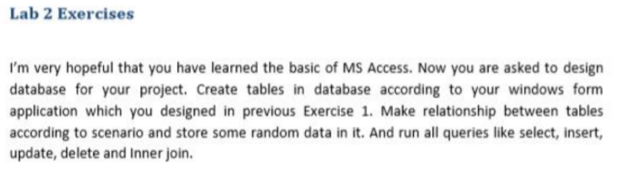

**Created a Database of Learning Teacher Info:**

**SQL QURIES:**

--creating a database

create database teacher_info

--using database

use teacher_info

--creating table for teacher info

create table teacher

(

teacher_id int primary key not null identity,

teacher_name nvarchar(30) not null,

teacher_email nvarchar(30) not null,

teacher_gender int foreign key references gender(gender_id) on delete cascade,

teacher_dept int foreign key references dept(dept_id) on delete cascade

)

--droping teacher info table

drop table teacher

--creating table for gender

create table gender(

gender_id int primary key not null identity,

gender_name nvarchar(30) not null

)

--creating table for dept

create table dept(

dept_id int primary key not null identity,

dept_name nvarchar(30) not null

)

--selecting teacher table

select * from teacher

--inserting vlaues for teacher table

insert into teacher values('Rafiq', 'rafiq.123', 1,1)

insert into teacher values('Areeb', 'areeb.123', 1,1)

insert into teacher values('Haseeb', 'haseeb.123', 1, 2)

insert into teacher values('Shahnaz', 'shehnaz.123', 2, 3)

insert into teacher values('Rehana', 'rehana.123', 2, 4)

--inserting vlaues for dept

insert into dept values( 'compScience')

insert into dept values( 'Mechanical')

insert into dept values( 'Physics')

insert into dept values ('Electrical')

--selecting dept table

select * from dept

--inserting values for gender

insert into gender values('male')

insert into gender values('female')

--selecting gender table

select * from gender

--updating teacher table

update teacher set teacher.teacher_name = 'sohaib' ,teacher.teacher_email = 'sohaib.123' where teacher.teacher_id = 3

--inner joining tables

select teacher.teacher_id , teacher.teacher_name, dept.dept_name, gender.gender_name from teacher

inner join dept on teacher.teacher_dept = dept.dept_id

inner join gender on teacher.teacher_gender = gender.gender_id

--executing tables

select * from gender

select * from dept

select * from teacher

**Design and Result:**

